

**Green University of Bangladesh**

**Department of Computer Science and Engineering(CSE)**

**Faculty of Sciences and Engineering**

**Semester: (Spring, Year:2024), B.Sc. in CSE (Day)**

**LAB REPORT NO 02**

**Course Title: Web Programming Lab**

**Course Code: CSE 302 Section: 213-D1**

**Lab Experiment Name:** Creating, Displaying HTML Pages using Basic HTML tags.

**Student Details**

| **Name** | **ID** |
| --- | --- |
| Sajid Rahman Rifan | 212902017 |

**Lab Date : 5 March 2024**

**Submission Date : 9 March 2024**

**Course Teacher’s Name : Md.Jahidul Islam**

**[For Teachers use only: Don’t Write Anything inside this box]**

| **Lab Report Status**  **Marks: ………………………………… Signature:.....................**  **Comments:.............................................. Date:..............................** |
| --- |

**1. TITLE OF THE LAB EXPERIMENT**

Creating, Displaying HTML Pages using Basic HTML tags.

**2. OBJECTIVES/AIM**

* Use basic HTML tags such as <html>, <head>, and <body> to structure the skeleton of the webpage.
* Employ essential tags like <h1>, <p>, <img>, and <a> to add headings, paragraphs, images, and hyperlinks to the webpage for content display and navigation.

**3. PROCEDURE / ANALYSIS / DESIGN**

**Heading:** Use the <h1> to <h6> tags to define headings, with <h1> being the largest and <h6> the smallest.

**Paragraph:** Enclose text within <p> tags to define paragraphs.

**Hyperlink:** Use the <a> tag with the "href" attribute to create hyperlinks. For example: <a href="https://example.com">Link Text</a>.

**Text Formatting:** Use tags like <strong> for bold text, <em> for italic text, <u> for underlined text, and <br> for line breaks.

**Image:** Insert an image using the <img> tag with the "src" attribute specifying the image URL. For example: <img src="image.jpg" alt="Description">.

**Video:** Embed videos using the <video> tag, specifying the video URL within the "src" attribute. Optionally, include controls using the "controls" attribute.

**Audio:** Embed audio files using the <audio> tag, specifying the audio file URL within the "src" attribute. Optionally, include controls using the "controls" attribute.

**Image as Link:** Simply wrap an <img> tag within an <a> tag to create an image link. For example:

<a href="https://example.com"><img src="image.jpg" alt="Description"></a>.

**4. IMPLEMENTATION**

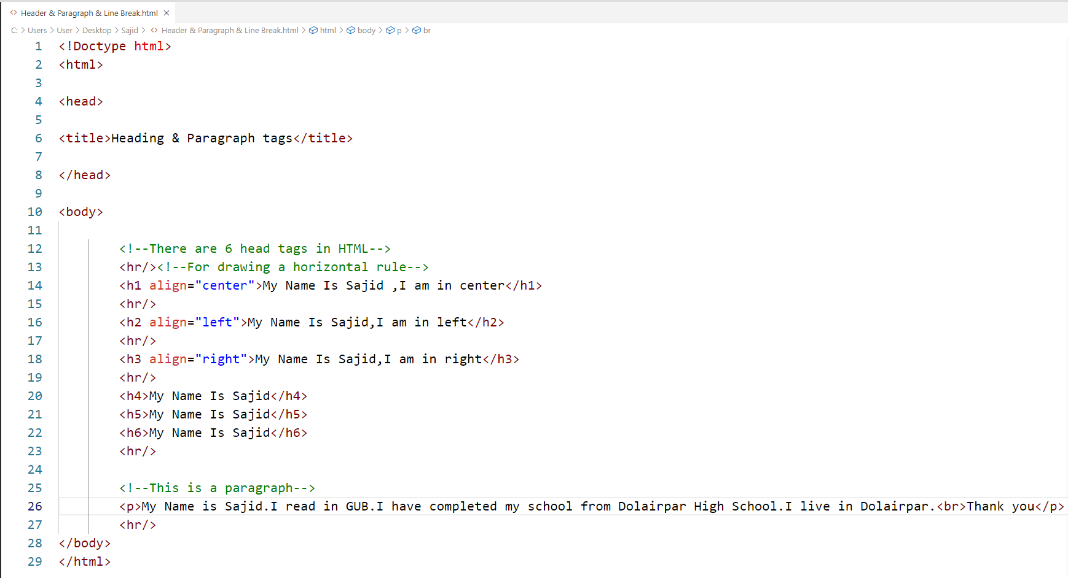

**Figure 1 :Code for HTML Heading & Paragraph & Line Break**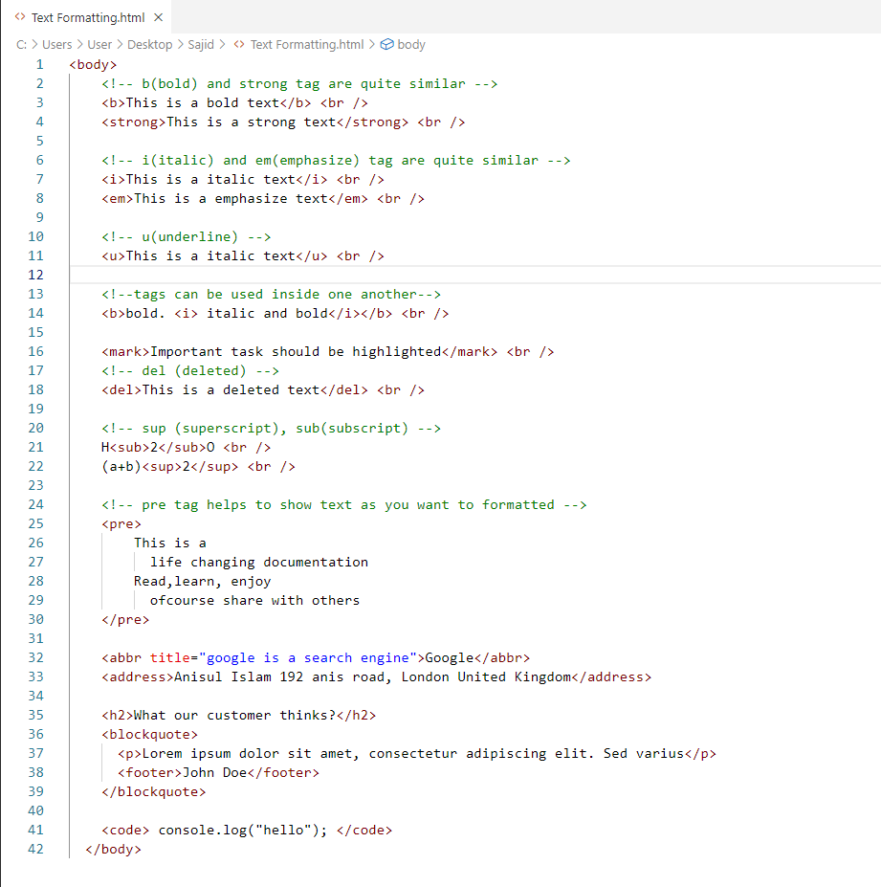

**Figure 2 :Code for HTML Text Formatting**

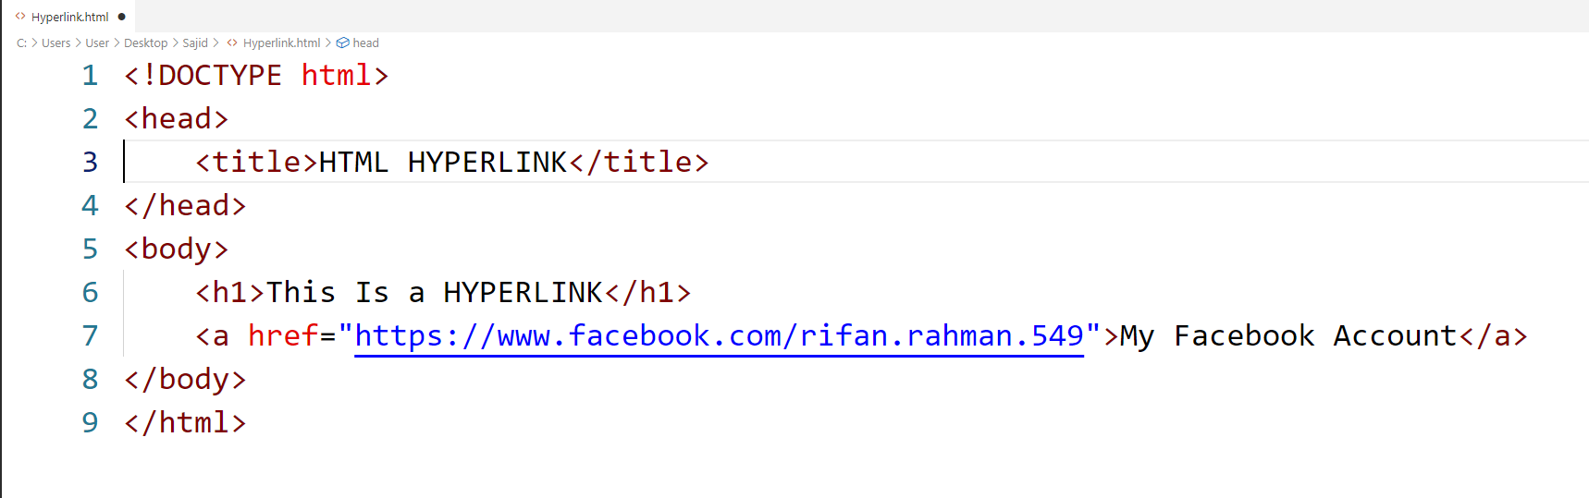

**Figure 3 :Code for HTML Hyperlink**

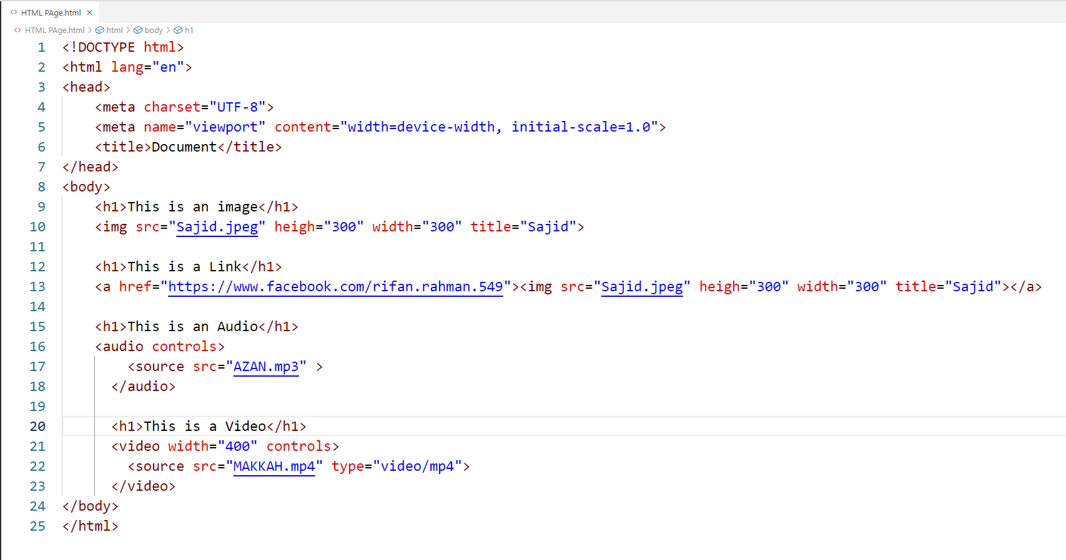

**Figure 4 :Code for HTML Image,Link,Audio & Video**

**5. TEST RESULT / OUTPUT**

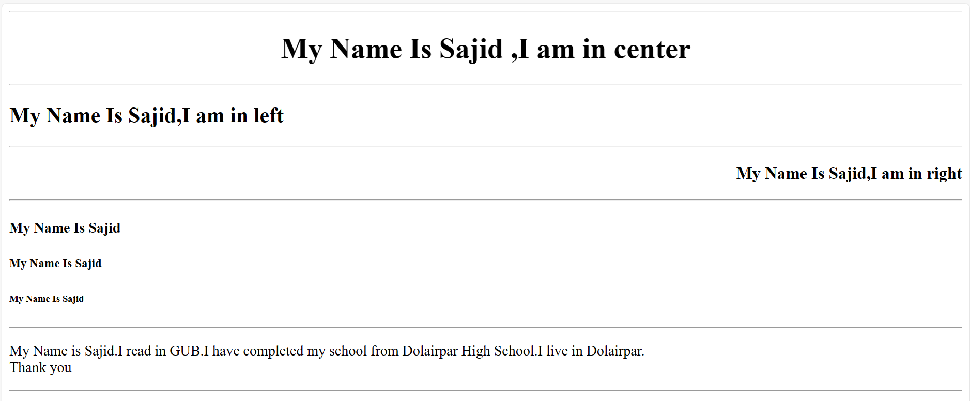

**Figure 5 :Output of HTML Heading & Paragraph & Line Break**



**Figure 6 :Output of HTML Hyperlink**

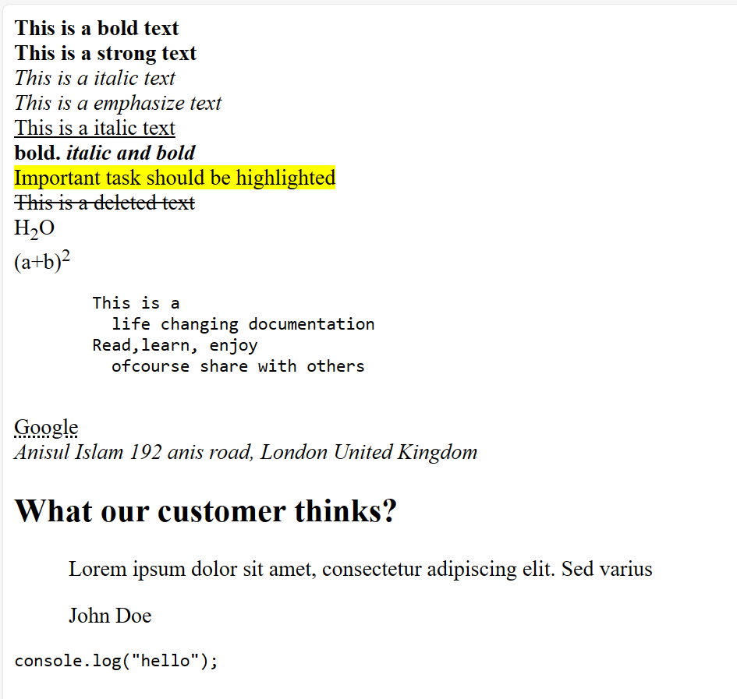

**Figure 7 :Output of HTML Text Formatting**

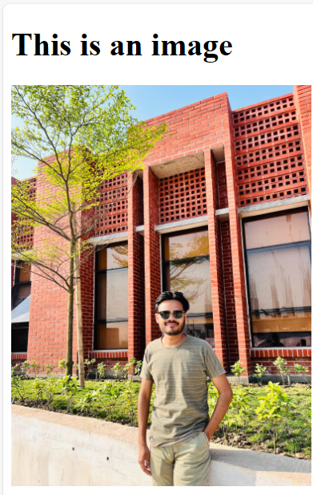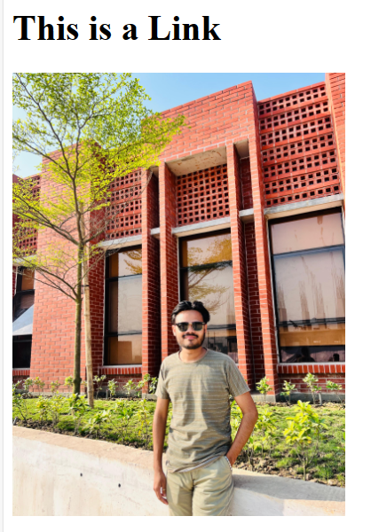

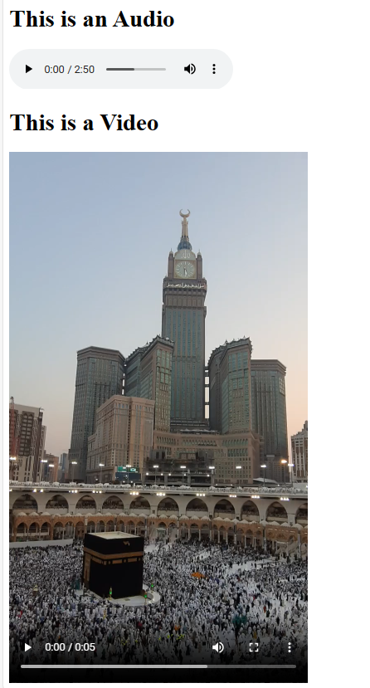

**Figure 8 :Output of HTML Image,Link,Audio&Video**

**6. ANALYSIS AND DISCUSSION**

Creating and displaying HTML pages using basic HTML tags is the foundation of web development. These tags, such as <html>, <head>, <title>, <body>, and <p>, structure content and define its appearance on a webpage. By understanding and using these fundamental tags, developers can create visually appealing and well-organized web pages that effectively convey information to users, forming the building blocks of the online experience.